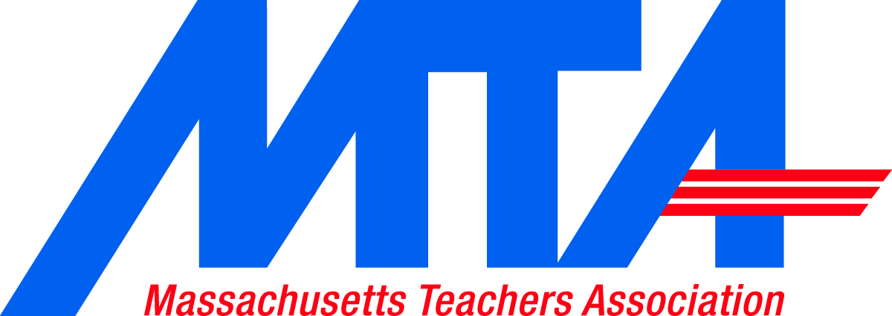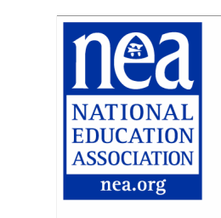

Invitation to Association Member to Join Local Implementation Team

Dear RECIPIENT NAME,

Massachusetts students, schools, and educators have a unique opportunity before them as we transition from the No Child Left Behind (NCLB) Act to the Every Student Succeeds Act (ESSA). Passage of ESSA provides the opportunity to return our focus to student learning (rather than testing) and create an accountability system that provides supports and resources.

NCLB relied heavily on the federal government to make decisions and create policy. ESSA turns away from this premise and emphasizes the importance of state and local control over education policies. ESSA also emphasizes the importance of current practitioner voice in all levels of decision-making. It is imperative that we are ready to make the decisions that will guide the future of public education in CITY or COUNTY NAME.

The LOCAL ASSOCIATION Education Association believes that successful implementation will require several discussions over the course of the next year and beyond as we determine policies that are not only beneficial for our students, but also for communities, schools, and educators. We are deeply committed to taking part in local discussions and decisions. As part of this commitment, LOCAL ASSOCIATION INITIAL EA is working to establish a local team that will examine ESSA, make recommendations, and help guide decision-making.

We are writing to request that you consider joining LOCAL ASSOCIATION INITIAL EA’s implementation team for ESSA discussion on DATE, TIME, LOCATION INFORMATION. Please contact CONTACT PERSON (EMAIL ADDRESS) by DATE to RSVP.

We look forward to collaborating with SCHOOL DIVISION NAME Public Schools, the SCHOOL DIVISION NAME School Board as well as other stakeholders to successfully implement ESSA by the 2017-2018 school year.

